TITLE (PLEASE CENTER, UPPERCASE USE Times New Roman 14PT., BOLD)

First Author¹, Second Author^{2,}*, and Third Author³ (Times New Roman 11pt., centered)

¹Full affiliation of first author, including country (Times New Roman 10pt. centered)

²Full affiliation of second author, including country

³List all affiliation in the same way

*Corresponding author: e-mail@e-mail.com (author initials)

Abstract
The abstract must be concise and should clearly articulate both the motivation for the study and its principal outcomes. The text should be self-contained, providing sufficient context for the reader without requiring reference to the other papers. Figures may be included if necessary; however, the inclusion of images requires a proportional reduction in the word count to ensure the submission does not exceed one page in total length. The abstract should not exceed 300 words. The body of the abstract must be formatted in Times New Roman, 11-point font, with left-justified alignment.
The corresponding author must be clearly identified, as in this template. The email address of the corresponding author should be provided alongside the respective affiliation. Submission of an abstract signifies that all co-authors have reviewed the document and consent to its submission.

Keywords: keyword 1; keyword 2; keyword 3. List max 5 pertinent keywords specific to the article yet reasonably common within the subject discipline (words in English)
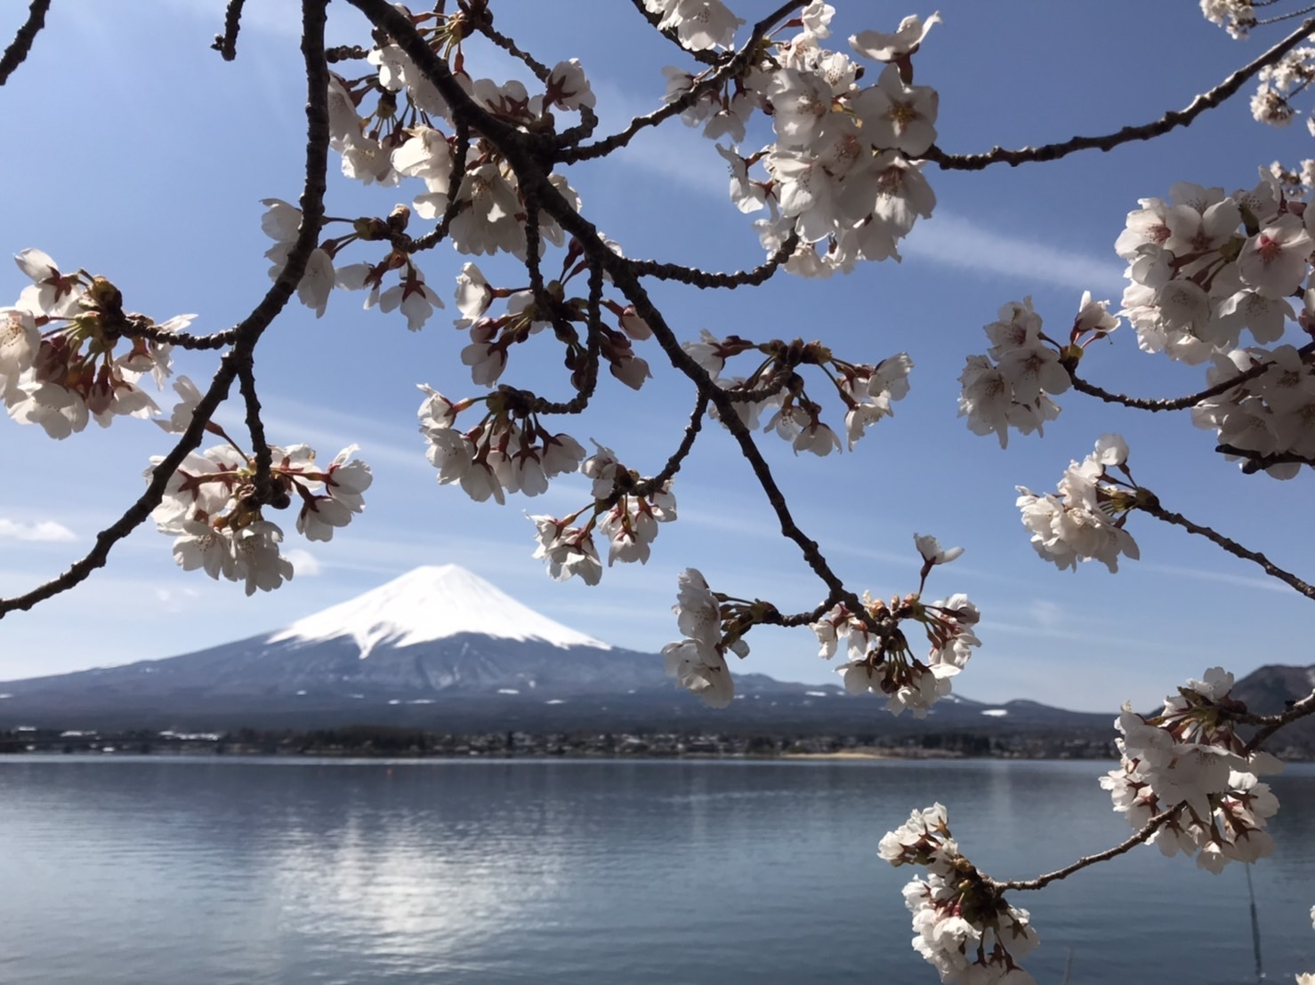
Please convert this docx file to pdf file, and rename it according to the name of the first author. For example: FirstAUTHOR_SEAJCCM2026.pdf
Figure 1 Figure captions must be formatted in 10-point Times New Roman, bold, and left-justified. All figures must be explicitly referenced within the abstract text.

