**Abstract Title with Times New Roman 14-Point Font**

First Author 1*, Second Author 2, ...

1 Affiliation of the fist author

2 Affiliation of the second author

…

*Corresponding Author: corresponding_author@email.com

**Keywords** one, two, …, less than five

The abstract should not exceed 2 pages but should be longer than 1 page to contain enough details for reviewing its merit. Times New Roman font should be used for the title and body text of the abstract. The abstract title should be 14-point font and all other text should be 12-point font. All authors and their affiliations as well as the corresponding author’s email address should be provided. The number of Keywords should be less than five.

Each paragraph of the abstract should use 1.15 spacing. One inch margins should be used all around. Text should be fully justified. The first word of each paragraph in the abstract should not be indented. There should be 10-point spacing between paragraphs in the abstract. There should be 18-point spacing between the Keywords and the first paragraph of the abstract. The file that is submitted must be in PDF format and must be named using the first and last name of the presenter of the paper following the convention “Lastname_Firstname.pdf.”

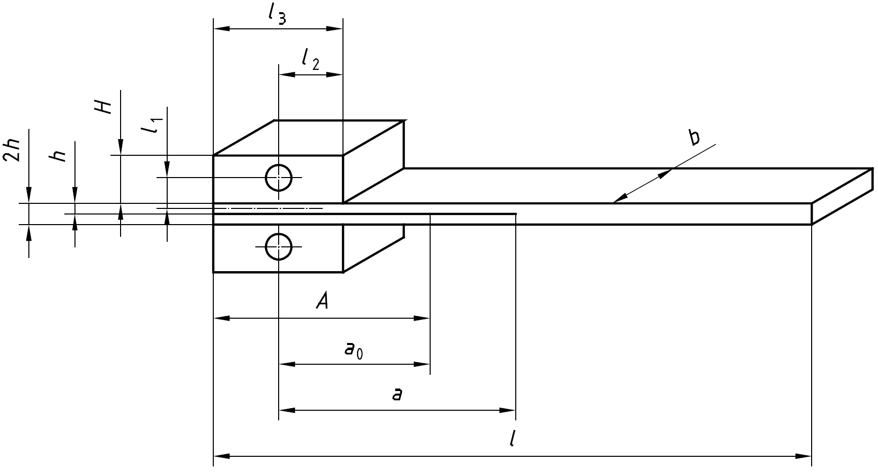

Figure 1. Example of a figure containing text.

Figures should be referred to as “Figure 1,” etc. Figure captions should be provided below the figures in 10-point Times New Roman font. Text within figures should be large enough to be easily readable. Table titles are to be placed above the table to use 10-point Times New Roman font, as shown. Figures and Tables may be embedded in the text or listed at the end of the abstract.

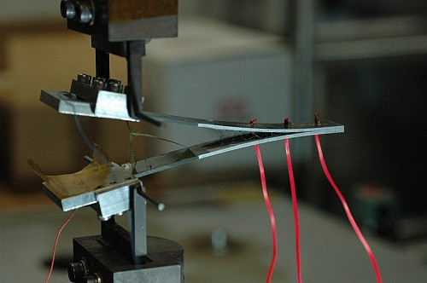

Figure 2. Figure captions should be Times New Roman with 10-point font.

Table 1. Example of a table.

|  |  |  |  |  |
| --- | --- | --- | --- | --- |
|  | Unit | Carbon fiber | Glass fiber | Tolerance |
| Width *b* | mm | 20 | 20 | ±0.5 |
| Minimum length *l* | mm | 125 | 125 | N/A |
| Thickness 2*h* | mm | 3 | 5 | ±0.1 |

The length of the abstract should be more than one page less than 2 pages. The final, PDF version of the abstract named “Lastname_Firstname.pdf” should be submitted via the following URL:

https:// TBD

**References**

1. Prokai-Tatrai K, Prokai L. Modifying peptide properties by prodrug design for enhanced transport into the CNS. Prog Drug Res. 2003;61:155–188.
2. Veronesi U, Maisonneuve P, Decensi A. Tamoxifen: an enduring star. J Natl Cancer Inst. 2007;99(4):258–260.
3. Patrias K. Interacting with the digital environment: modern scientific publishing. Proceedings of the 46th Annual Meeting of the Council of Science Editors; 2003 May 3–6; Pittsburgh, PA.
4. Van de Velde R, Degoulet P. Clinical information systems: a component- based approach. New York (NY): Springer; 2003.
5. Sumner P, Mollon JD. Did primate trichromacy evolve for frugivory or folivory? In: Mollon JD, Pokorny J, Knoblauch K, editors. New York (NY): Oxford University Press; 2003. p. 21–30.